2022年中欧物流、信息化、管理和服务科学博士生院暑期学校基本信息
简介
2022年中欧物流、信息化、管理和服务科学博士生院暑期学校（简称中欧博士院暑期学校）是由西班牙加泰罗尼亚理工大学（UPC）、北京交通大学信息管理理论与技术国际研究中心（ICIR）主办、北京物资学院承办，香港理工大学和北京交通大学国际教育学院协办，旨在结合各方在物流和管理科学领域的优势，促进学科整合，创新博士培养模式。中欧博士生院暑期学校已经连续成功举办6届（见附录A），通过为学员提供高水平的学术讲座、多样化的学术研讨和丰富的文化交流体验，建立物流、信息化、管理和服务科学前沿的国际学术交流平台。
2022年中欧博士生院暑期学校基本信息
•学科领域：物流、信息化、管理和服务科学
•行程安排：见附录B
•时间：2022年7月21日至7月26日
•地点：线上+北京交通大学
•主办方：北京交通大学ICIR，西班牙加泰罗尼亚理工大学
•协办方：北京物资学院，香港理工大学，北京交通大学国际教育学院
•中欧博士生院与LISS 2022和IEIS 2022委员会之间达成协议，所有学员都可以免费参加两个国际会议（LISS 2022和IEIS 2022）的所有主题演讲和研讨会。为参与者提供感触杰出学者前沿思想、深入学习与交流的机会。
申请条件与要求
•申请人为国内外联盟高校全日制博士生
•疫情防控允许情况下，申请人为北京疫情低风险区全日制博士生可参加线下活动
•申请人的研究领域仅限于物流和供应链、信息管理和信息系统、管理科学和工程领域（或交叉领域）
•申请人需提交其科研工作的简介或摘要
•每位申请人需在暑期学校的博士研讨会上进行15-20分钟的科研工作汇报
•申请截止时间：2022年7月10日24:00
联系信息
•联系人：张艳萍博士，邮箱：zyp1537399@163.com; 手机/微信：15373998416

2022 Doctoral Consortium of Sino-EU Doctoral School for Logistics, Information, Management, and Service Science
Introduction
The 2022 doctoral consortium of Sino-EU Doctoral School for Logistics, Information Management and Service Sciences (Sino-EU Doctoral School) is hosted by Universitat Politècnica de Catalunya Barcelona Tech (UPC) and International Center for Informatics Research of Beijing Jiaotong University (ICIR). 2022 Sino-EU Doctoral School is organized by Beiing Wuzi University, and co-organized by Hong Kong Polytechnic University and School of International Education as well as the College of International Education of Beijing Jiaotong University to promote discipline integration and innovate doctoral training mode, with the advantages of each institute in fields of logistics and management science.
The doctoral consortium, having been through 6 successful consecutive years (see Appendix A), aims to establish a platform of international academic exchange on the cutting edge of logistics, information, management, and service sciences, by providing the participants with top academic lectures, varieties of seminars, multicultural experience, etc.
Key information of the 2022 doctoral consortium
- Scope: Cutting edge of logistics, information, management, and service sciences
- Program: See appendix B
- Time: July 21st –July 26th, 2022
- Place: Virtual+ Beijing Jiaotong University
- Sponsors: International Center for Informatics Research of Beijing Jiaotong University, Universitat Politècnica de Catalunya Barcelona Tech
- Co-organizers: Beijing Wuzi University, Hong Kong Polytechnic University, College of International Education of Beijing Jiaotong University

Additional Benefit
- All the participants enjoy a free access to the keynote speeches and regular workshops of two international conferences (LISS2022 and IEIS2022), thanks to the established agreements between the doctoral consortium and the committees of LISS2022 and IEIS2022, which would enable participants to touch the cutting-edge thoughts of distinguished masters and develop deep communication with them.
Enrollment Targets and Requirement
- Enrollment targets: Full-time Ph.D students (When the epidemic prevention and control permits, students from domestic alliance universities in low-risk regions can attend on-site activities)
- Requirements:
- The applicants are limited to those focusing on topics in the fields (or intersectional fields) of logistics and supply chain, information management and system, management science and engineering.
- The applicant should submit an abstract describing his work for exchange.
- Every applicant is expected to give a 15-20 minutes’ talk on his/her recent innovative work in the doctoral consortium seminars.
- Closing date for application: 24:00 10th July, 2022

Contact Information
- Contact: Dr. Yanping Zhang, Email: zyp1537399@163.com; Mobile/Wechat：15373998416.

附录A / Appendix A
Sweet Memories of the Doctoral Consortium of SEDSLIMSS
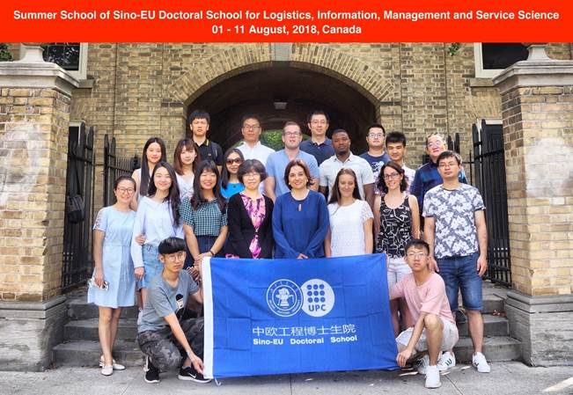
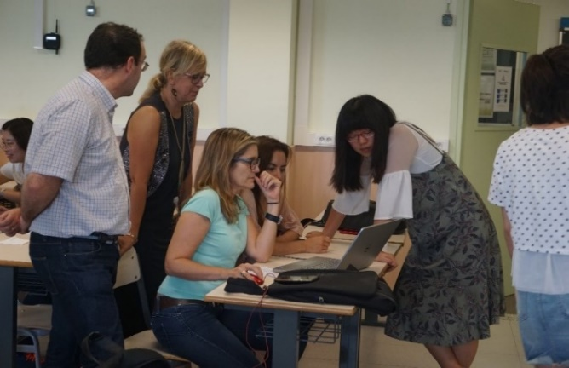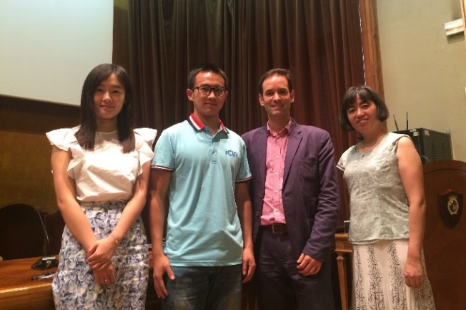
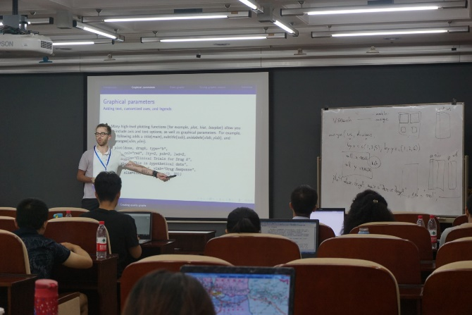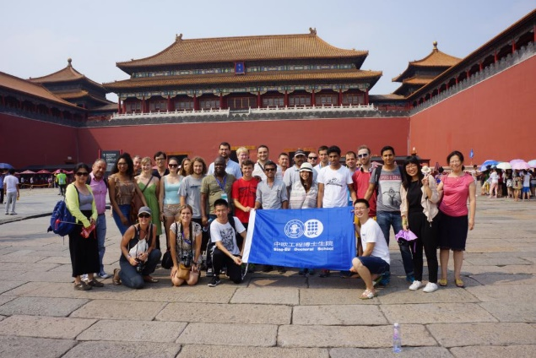

附录B / Appendix B
2022年博士生暑期学校详细行程
日期 | 时间  (北京时间) | 活动  （线上+线下）
7/20/2022 | 9:00-12:00 | 线下注册登记
 | 12:00-13:00 | 午餐
 | 13:00-16:30 | 线下注册登记
 | 17:00-20:00 | 晚餐
7/21/2022 | 9:00-9:30 | 中欧博士生院暑期学校开幕式 (线上+线下)
 | 9:30-11:00 | 教授授课 (线上)  演讲嘉宾：Professor Gautam Kamath, University of Waterloo  题目：Private machine learning
 | 11:10-12:00 | 学生自我介绍及破冰游戏 (线上+线下)
 | 12:00-14:00 | 休息
 | 14:00-22:00 | LISS 2022和IEIS 2022大会开幕式 (线上)  LISS 2022和IEIS 2022大会主题演讲 (线上)
7/22/2022 | 9:00-11:00 | LISS 2022和IEIS 2022大会主题演讲 (线上)
 | 12:00-14:00 | 休息
 | 14:00-15:00 | 交大评论《我国网信产业链短板环节及自主创新白皮书》发布会 (线上+线下)  邀请嘉宾：张宏科院士，北京交通大学
 | 15:30-17:00 | 博士生分组学术交流研讨会 (线上+线下)
 | 17:00-18:00 | 休息
 | 18:00-22:00 | LISS 2022和IEIS 2022闭幕式 (线上)
7/23/2022 | 9:00-10:30 | 教授授课 (线上)  演讲嘉宾：Professor Robin Qiu,  The Pennsylvania State University
 | 10:40-12:00 | 主题研讨会 (线上)  题目：从博士生到青年老师的打怪升级之路  邀请嘉宾：青年教师，往届暑期学校优秀学员  陈东华（对外经贸大学）、向杰（四川大学）、张一（物资学院）、王军（北京化工大学）、张名扬（北京林业大学）、王艾（北京科技大学）
 | 12:00-14:00 | 休息
 | 14:00-15:30 | 企业讲座 (线上)
 | 15:40-18:00 | 博士生分组学术交流研讨会 (线上+线下)
7/24/2022 | 9:00-10:30 | 企业讲座 (线上)
 | 10:40-12:00 | 主题研讨会 (线上)
 | 12:00-14:00 | 休息
 | 14:00-15:30 | 企业讲座 (线上)
 | 15:40-18:00 | 博士生分组学术交流研讨会 (线上+线下)
7/25/2022 | 9:00-10:30 | 教授授课 (线上)  演讲嘉宾：Professor Sylvia Gao, University of Auckland  题目：How to do quant research?
 | 10:40-12:10 | 教授授课 (线上)
 | 12:10-14:00 | 休息
 | 14:00-15:30 | 教授授课 (线上)  巴塞罗那加泰罗尼亚理工大学
 | 15:40-18:00 | 博士生分组学术交流研讨会 (线上+线下)
7/26/2022 | 9:00-10:30 | 教授授课 (线上)  演讲嘉宾：Professor Xinghua Zhang,  Beijing Jiaotong University
 | 10:40-12:10 | 教授授课 (线上)
 | 12:10-14:00 | 休息
 | 14:00-15:30 | 教授授课 (线上)  巴塞罗那加泰罗尼亚理工大学
 | 15:40-16:40 | 博士生分组学术交流研讨会 (线上+线下)
 | 17:00-18:00 | 毕业典礼 (线上+线下)

Program of the 2022 doctoral consortium
Date | Time  (GMT+8) | Activities  （Online+On-site）
7/20/2022 | 9:00-12:00 | Registration
 | 12:00-13:00 | Lunch
 | 13:00-16:30 | Registration
 | 17:00-20:00 | Dinner
7/21/2022 | 9:00-9:30 | Opening ceremony (Virtual + On-site)
 | 9:30-11:00 | Masterclass (Virtual)  Guest speaker: Professor Gautam Kamath, University of Waterloo  Topic：Private machine learning
 | 11:10-12:00 | Student self-introduction and ice-breaker
 | 12:00-14:00 | Break
 | 14:00-22:00 | LISS 2022 and IEIS 2022 Conference opening ceremony (Virtual)  Keynote speeches in LISS 2022 and IEIS 2022 (Virtual)
7/22/2022 | 9:00-11:00 | Keynote speeches in LISS 2022 and IEIS 2022 (Virtual)
 | 12:00-14:00 | Break
 | 14:00-15:00 | "White Paper on Short Links and Independent Innovation of Chinese Internet Information Industry Chain" from Jiaotong University Review Release Announcements (Virtual + On-site)  Invited guest: Professor Hongke Zhang, Academician, Beijing Jiaotong University
 | 15:30-17:00 | Doctoral student group seminar (Virtual + On-site)
 | 17:00-18:00 | Break
 | 18:00-22:00 | LISS 2022 and IEIS 2022 Conference closing ceremony (Virtual)
7/23/2022 | 9:00-10:30 | Masterclass (Virtual)  Guest speaker：Professor Robin Qiu, The Pennsylvania State University
 | 10:40-12:00 | Panel Talk (Virtual)  Topic: The transformation from doctoral students to young faculties.  Invited guests: young faculties from outstanding students of previous summer schools  Donghua Chen (University of International Business and Economics), Jie Xiang (Sichuan University), Yi Zhang (School of Materials and Materials), Jun Wang (Beijing University of Chemical Technology), Mingyang Zhang (Beijing Forestry University), Ai Wang (Beijing University of Science and Technology)
 | 12:00-14:00 | Break
 | 14:00-15:30 | Corporate senior leadership seminar (Virtual)
 | 15:40-18:00 | Doctoral student group seminar (Virtual + On-site)
7/24/2022 | 9:00-10:30 | Corporate senior leadership seminar (Virtual)
 | 10:40-12:00 | Panel Talk (Virtual)
 | 12:00-14:00 | Break
 | 14:00-15:30 | Corporate senior leadership seminar (Virtual)
 | 15:40-18:00 | Doctoral student group seminar (Virtual + On-site)
7/25/2022 | 9:00-10:30 | Masterclass (Virtual)  Guest speaker：Professor Sylvia Gao, University of Auckland  Topic：How to do quant research?
 | 10:40-12:10 | Masterclass (Virtual)
 | 12:10-14:00 | Break
 | 14:00-15:30 | Masterclass (Virtual)  Universitat Politècnica de Catalunya Barcelona Tech
 | 15:40-18:00 | Doctoral student group seminar (Virtual + On-site)
7/26/2022 | 9:00-10:30 | Masterclass (Virtual)  Guest speaker：Professor Xinghua Zhang,  Beijing Jiaotong University
 | 10:40-12:10 | Masterclass (Virtual)
 | 12:10-14:00 | Break
 | 14:00-15:30 | Masterclass (Virtual)  Universitat Politècnica de Catalunya Barcelona Tech
 | 15:40-16:40 | Doctoral student group seminar (Virtual + On-site)
 | 17:00-18:00 | Closing ceremony (Virtual + On-site)

